**Name: Merin joseph**

**Roll No:20**

**Batch: MCA -B**

**Date:24-05-2022**

**ADVANCED DATABASE MANAGEMENT LAB**

**Experiment No.: 8**

**Aim**

Installation of MongoDB on windows

**Procedure**

The installers for MongoDB are available in both the 32-bit and 64-bit format. The 32-bit installers are good for development and test environments. But for production environments you should use the 64-bit installers. Otherwise, you can be limited to the amount of data that can be stored within MongoDB.

**Download & Install MongoDB on Windows**

The following steps can be used to install MongoDB on Windows 10:

**Step 1:**

After downloading MongoDB, open the msi file and click next.

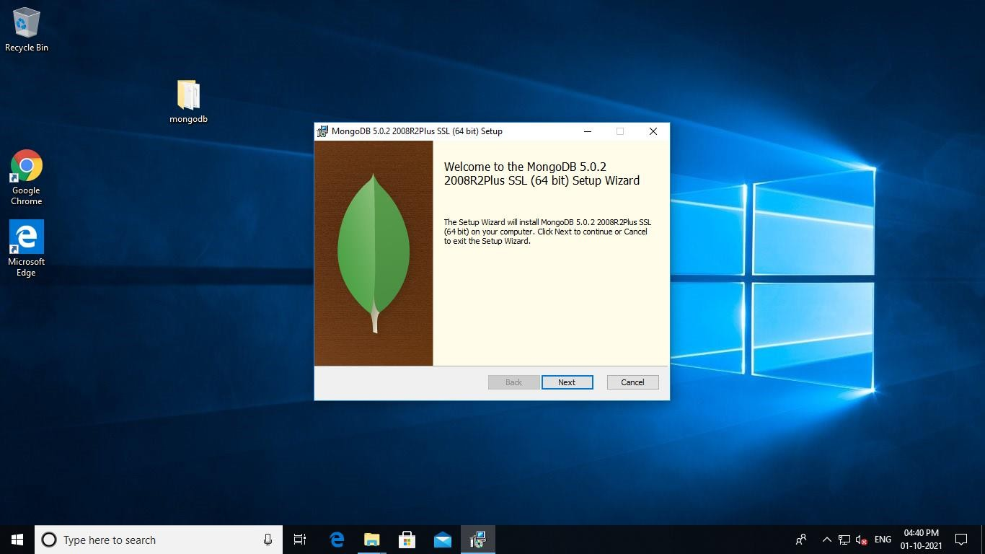

**Step 2:**

1. Accept the End-User License Agreement
2. Click Next

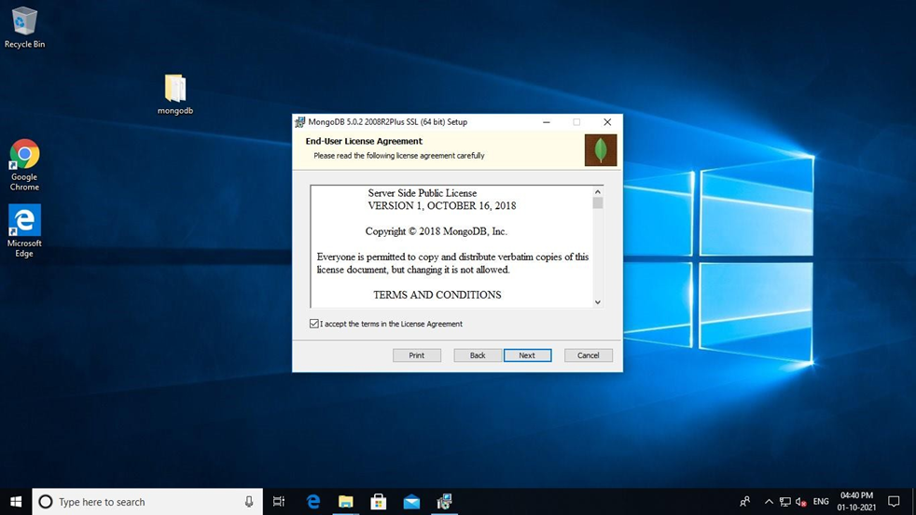

**Step 3:**

Click on the "complete" button to install all of the components. The custom option can be used to install selective components or if you want to change the location of the installation.

1. Select “Run service as Network Service user”. Make a note of the data directory, we’ll need this later.
2. Click Next

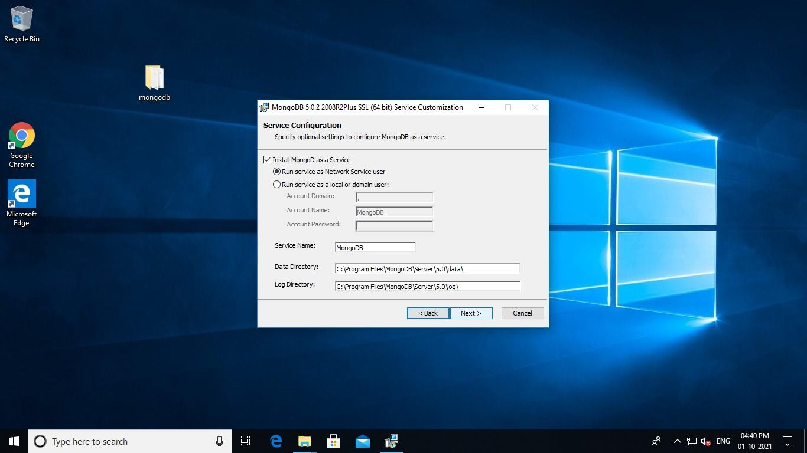

**Step 4:**

Click on the Install button to start the installation. Installation begins.

Click next once completed.

Click on the Finish button to complete the installation.

